

**School of Engineering and Applied Science,**

**Ahmedabad University**

**CSE300 Software Engineering**

**Weekly Report**

**Guided By: Prof Khushru Doctor**

**TA Muskan Matwani**

**TA Anupama Nair**

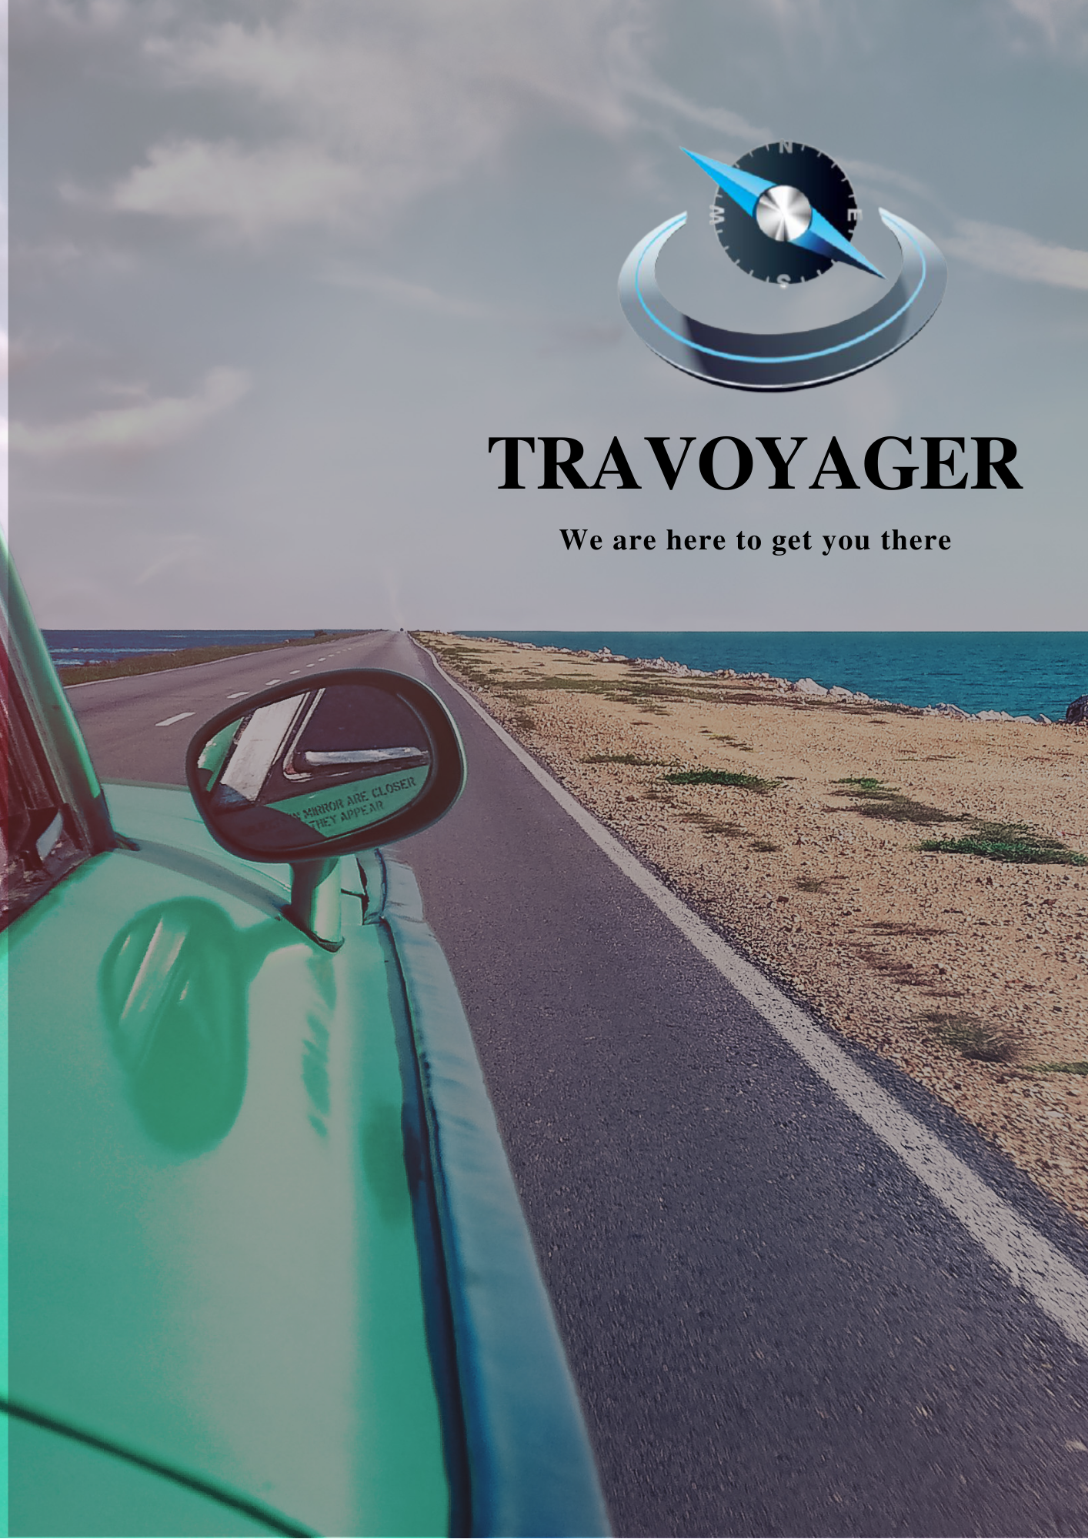

**WEEKLY MEETING REPORT - 4**

**Agenda** - Tools and Technologies, Development Platform Selection

**Date and Time**

**________________________________________________________________________________________________________________________________________________________________________________________________________________________________________________________________________________________________________________________________________________________________________________________________________________________________**

March 3, 2021 04:00P.M.-5:30P.M.

**Location**

**________________________________________________________________________________________________________________________________________________________________________________________________________________________________________________________________________________________________________________________________________________________________________________________________________________________________**

Google Meet

**Schedule**

**________________________________________________________________________________________________________________________________________________________________________________________________________________________________________________________________________________________________________________________________________________________________________________________________________________________________**

|  |  |
| --- | --- |
| **Time** | **Description** |
| 4:00-4:05 P.M. | Attendance |
| 4:05-4:40 P.M. | Tools discussion |
| 4:40-4:45 P.M. | Summary |
| 4:45 P.M. | Meeting Adjourned |

**Details**

**________________________________________________________________________________________________________________________________________________________________________________________________________________________________________________________________________________________________________________________________________________________________________________________________________________________________**

1.Tools discussed:

1. HTML, CSS
2. JS
3. Django
4. ReactJS
5. Java
6. Flask
7. PHP
8. Android

2. Collaboration tools:

1. Github
2. Google Drive
3. draw.io
4. Lucidchart

**Conclusion**

**________________________________________________________________________________________________________________________________________________________________________________________________________________________________________________________________________________________________________________________________________________________________________________________________________________________________**

1. From the above tools,
   1. Django for web development
   2. Github for project sharing
   3. Lucidchart and draw.io for creating diagrams
   4. Google Drive for maintaining the resources

**Next Meeting Details**

**________________________________________________________________________________________________________________________________________________________________________________________________________________________________________________________________________________________________________________________________________________________________________________________________________________________________**

March 7, 2021 4:00-5:30P.M.

**Next Agenda**

**________________________________________________________________________________________________________________________________________________________________________________________________________________________________________________________________________________________________________________________________________________________________________________________________________________________________**

Sprint Formulation and ER diagram construction